Touchstone 4 Template
Interactivity and Client-Side Data
Name: | Suraj Mangrati
Course: | Introduction to Web Development
Date: | 10/21/2026
Selected Client: | North Star Bakery

Important: Continue using the same client and website from Touchstone Task 2 and Touchstone 3. Submit this completed template as your single Touchstone file. Your linked project must contain the updated HTML, CSS, and JavaScript files.

Section 1: Project Link
Paste the URL to your public GitHub repository for this project. The repository should include all updated HTML, CSS, and JavaScript files required for this Touchstone.
Working Project Link: | North Star Bakery | Home
Repository Link (if different): | devN4t3d/TouchStone3IntroToWebDev

Section 2: Implementation Explanation
Respond to every prompt below. Each response should be 2–4 sentences, refer to a specific element or behavior from your project, and explain how the implementation works. Reference your screenshots where requested.
Feature Purpose
Explain what your interactive feature helps users do and how it supports your client’s goals or audience. Identify the page where the feature appears and describe the user need it addresses.
Reference Screenshot 1 in your response.
Response:
The interactive feature is a products favorite feature in the products page. It allows customers to easily add products to their favorites list while browsing the products catalog.

User Interaction
Describe how a user interacts with the feature step by step. Explain what JavaScript changes on the page after the user clicks, selects, or enters information.
Include the key action and the visible result.
Response:
The user clicks on a ‘Add to Favorites’ button at the bottom of a product listing. The javascript then pushes this product into a list of liked items, and then modifies the page’s html so that the favorited item is displayed in a list of favorite items.

Form Validation
Identify at least two JavaScript validation checks you added to your form. Explain how invalid submission is prevented and how feedback appears near the relevant fields so users can correct their entries.
Reference Screenshot 2 and quote or summarize at least one error message.
Response:
Fields have been set as mandatory (required) and there have also been character limits introduced. “Please enter your name (at least 2 characters)” makes it a requirement to have more than 2 characters as the name, to ensure that names are properly input.

Data Storage
State whether you used localStorage or sessionStorage. Explain what data is stored, when it is saved, and when it is loaded again. Describe how this improves the user experience.
Reference Screenshot 3 and identify the restored or remembered data.
Response:
Favorite products are stored in local storage. They are saved when a user clicks on the ‘Add to Favorites’ button. This improves the user experience, since users do not have to keep track of all products that they liked, and can instead store them away safely.

Technical Design
Explain how functions organize your JavaScript and how arrays or objects manage data. Name at least one function and one array or object, then describe what each does in your implementation.
For Advanced performance, the rubric expects at least two arrays or at least two objects.
Response:
The functions make it easy to separate commonly used steps, so that instead of writing it several times, it written only once, and called several times as needed. The objects are used to store records within the browser, for easier access from local storage.
Sample function is validateForm, which is called before the form is submitted. It ensures that all fields have been correctly populated.
Sample object is bakeryProducts, and it stores a catalog of the items available in the bakery.

Challenges Encountered
Describe one specific problem you encountered while building or testing the feature, validation, or storage. Explain what was not working, how you identified the cause, and what change fixed it.
Focus on a real implementation decision rather than a general statement.
Response:
It is a challenge to upload some files to github, notably the video file, since it is more than the 20mb github limit.This has affected the final appearance of the site.

Section 3: Technical and Submission Checklist
Check each item after testing your project.
☐ One meaningful JavaScript feature responds to a click, selection, or user input.
☐ The feature updates the page dynamically and clearly supports the client’s goals.
☐ JavaScript is organized into multiple functions rather than one large block.
☐ At least one array or object is used to manage data.
☐ For Advanced performance, at least two arrays or at least two objects are used.
☐ At least two JavaScript validation checks are implemented.
☐ Invalid form submission is prevented.
☐ Clear validation feedback appears near the relevant fields.
☐ Users can correct errors without losing the information they already entered.
☐ localStorage or sessionStorage saves at least one meaningful piece of data.
☐ Stored data is loaded when the relevant page opens or reloads.
☐ All previous HTML, CSS, navigation, media, and form functionality still works.
☐ The working project link is included and opens without requiring sign-in.
☐ All six explanation sections are complete and use project-specific examples.
☐ At least three screenshots and captions are included below.

Section 4: Screenshots
Insert at least three clear screenshots. Crop each image so the relevant feature is easy to see, and add a short caption that explains what the screenshot proves.
Screenshot 1: Interactive Feature in Use
Show the feature after a user action and the resulting dynamic update on the page.
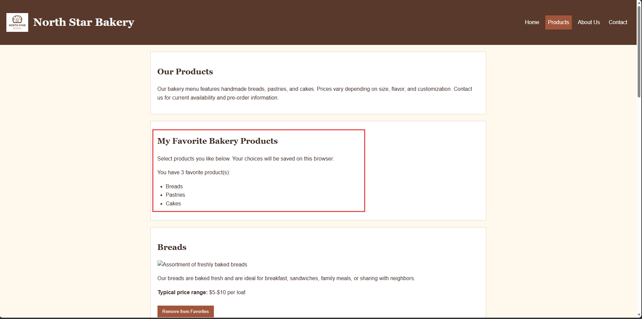
Caption: Interactive Feature – Product Favorites
Screenshot 2: Form Validation Feedback
Show at least two validation messages displayed near the relevant fields while submission is prevented.
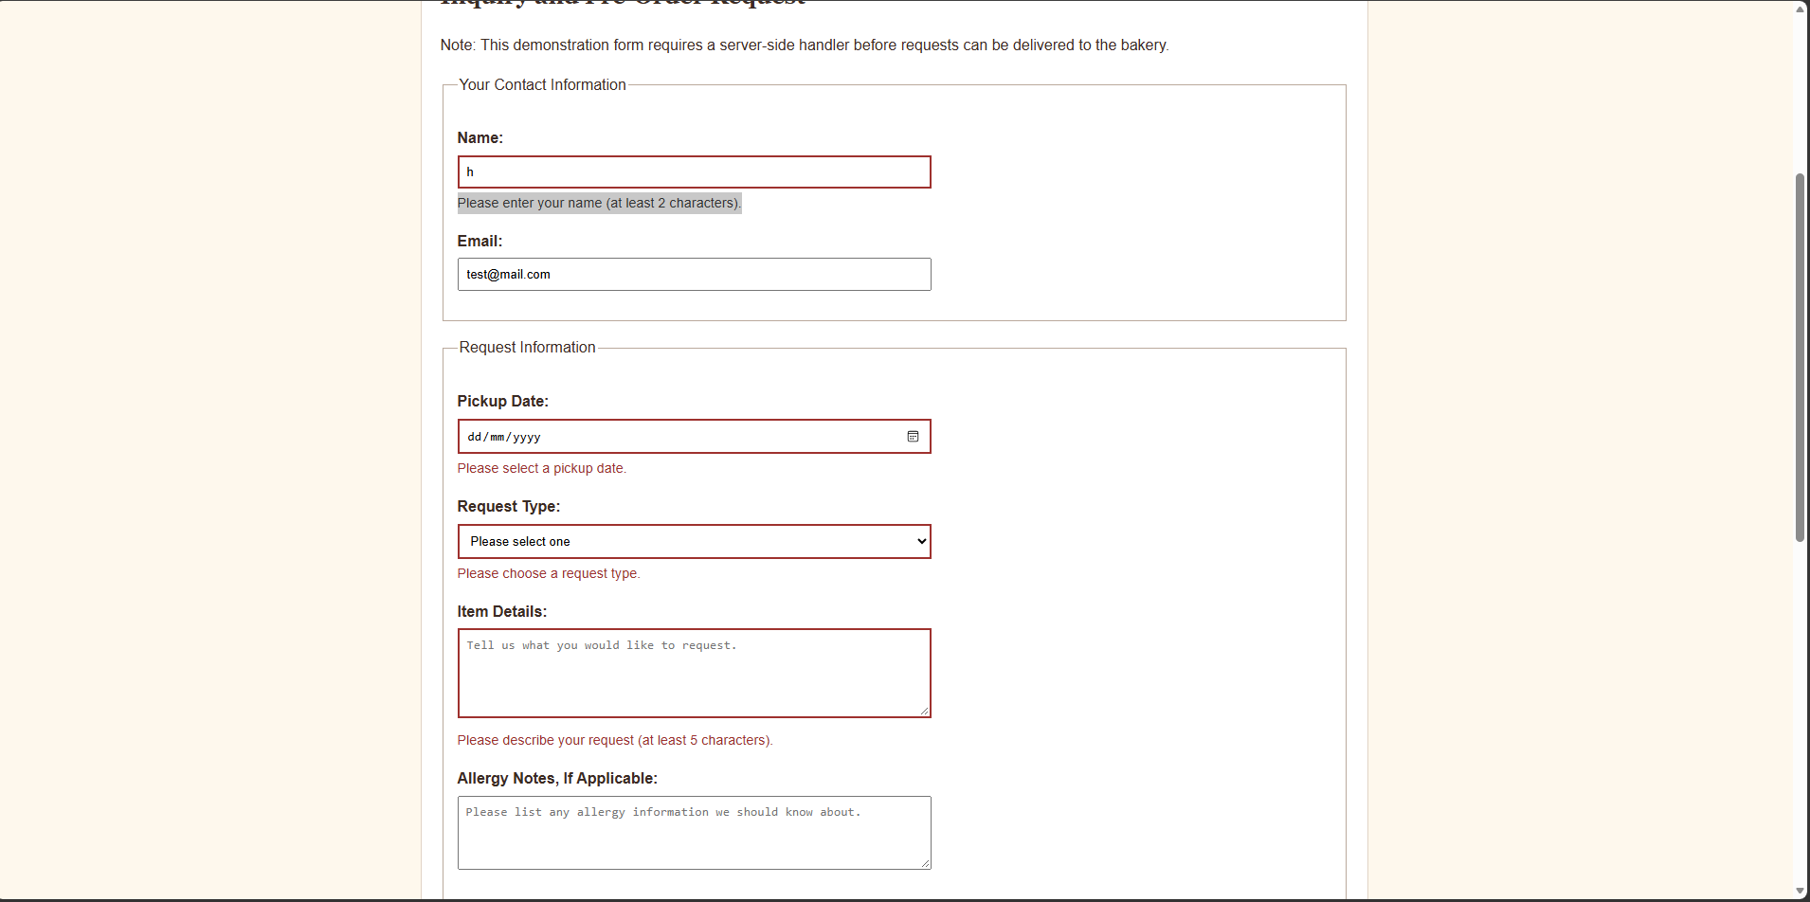
Caption: Data validation exceptions in contact page
Screenshot 3: Browser Storage Working
Show data restored after a refresh or return visit, such as a remembered selection, saved favorite, or pre-filled field.
Caption: Products stored in local storage.

Section 5: Final Review
☐ The interactive feature works as expected after repeated testing.
☐ The page updates dynamically when the user takes the intended action.
☐ Validation prevents invalid submission and messages appear near fields.
☐ Valid form entries can proceed without unnecessary errors.
☐ Stored data saves and reloads correctly after refreshing or reopening the page.
☐ No JavaScript errors appear in the browser console during normal use.
☐ Navigation and relative file paths work across all pages.
☐ The project remains readable and usable at mobile and desktop widths.
☐ The submitted link and all screenshots match the final version of the project.

Section 1: GitHub Repository
Paste the URL to your public GitHub repository for this project. The repository should include all updated HTML, CSS, and JavaScript files required for this Touchstone.
Repository URL:
devN4t3d/TouchStone3IntroToWebDev

Updated Final Review Items
- ☐ Public GitHub repository link included
- ☐ Repository opens without requiring login
- ☐ Repository contains all updated HTML, CSS, and JavaScript files
- ☐ Interactive feature works as expected
- ☐ Form validation prevents invalid submission
- ☐ Feedback appears near the relevant fields
- ☐ Stored data persists correctly
- ☐ Previous HTML and CSS functionality remains intact

